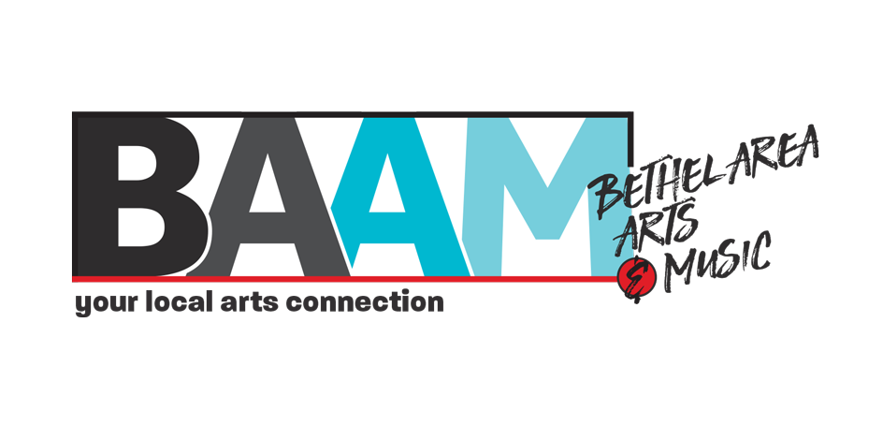
BAAM Art Market
July 10, August 7, November 27
10am – 4pm
The Gem, 48 Cross St
The Phibrook Place, 162 Main St

Exhibitor Application
DUE BY JUNE 16TH
Please contact us after the 16th if you are interested, we may have space!

Rules for all exhibitors:
- BAAM Art Market is a rain or shine event.
- Exhibitors may choose to apply for one, two, or all three markets.
- Booth fees: $40 per market or $100 for all three.
- Exhibitors must staff their booths from 10am-4pm unless severe weather becomes a factor.
- Set-up times: Saturday, July 10, 7-10:00am, Saturday, August 7, 7-10:00am, Saturday, November 27, 7-10:00am
- Vendors must be set up by 10am and vehicles moved to off-street parking.
- Space: Your 10’x10’ tent plus 2’ of clearance on each side = 14’x14’ total space.
- Spaces will be distanced from each other to accommodate social distancing.
- Tents, chairs, and displays are NOT provided.
- Tents must be staked if on grass and weighted if on concrete.
- Location or designated boundaries of any booth space may not be changed.
- Pets must be on a leash and waste removed.
- BAAM Art Markets are a non-smoking event.
- $10 fee for all cancellations before July 1st.
- No refunds after July 1st 2021, unless BAAM cancels this event due to COVID19 guidelines or severe weather. We will then offer a full refund with no cancellation fee.

Business/Organization: _________________________________________________________________________
Contact Person: _______________________________________________________________________________
Mailing Address: _________________________________City_______________________State_____Zip________
Phone: ______________________________________ Cell Phone: _____________________________________
Email________________________________________________________________________________________
Website, Facebook, or Etsy Address________________________________________________________________

DESCRIPTION OF WORK

Review Committee: The BAAM Art Market Review Committee is examining ALL applications according to the following guidelines:
- Decisions are made based on quality, pricing, and diversity of work.
- Each exhibitor must sell their own original design. Imports will not be accepted.
- If your application is not accepted, you will not be charged a fee.

Art/Craft Type – Check all that apply.

  - Acrylic or Oil Painting
- Baskets - Hand-woven
- Batik
- Fabrics - Painted
- Fiber Art
- Glass- Etching
- Glass - Blown/Torch
  - Glass – Stained
- Jewelry - Fine Handmade
- Oil
  - Pastels
  - Photography
- Pottery
- Re-purposing/Recycling
- Sculpture
  - Watercolor
- Weavings
- Woodworking/Carving

- Other
_______________________________________________________________________________________

EXHIBITORS: Please describe your work, the creative process, and send 2 photos of your artwork if you do not have a website, Facebook containing images of your work, or Etsy page.

Product Price Range: Low: $_______ to High: $_______

Need Electricity? Yes ______ No ______

Preferred Space location: Space preference is not guaranteed

- I would prefer to be outside of The Gem.
- I would prefer to be outside of The Philbrook Place.
- I have no preference.

Specific requests ___________________________________________________________________________________
___________________________________________________________________________________

Payment Information
Exhibitor Space(s):
July 10th Number of 14’x14’ spaces _________ X $40/space = ___________
August 7th Number of 14’x14’ spaces _________ X $40/space = ___________
November 26th Number of 14’x14’ spaces _________ X $40/space = ___________
Total = ___________

_____ I have enclosed a check or money order (Made payable to Bethel Area Arts & Music)

_____ Please charge my credit card (Visa, MasterCard, Discover, American Express):

Name on card _____________________________________________________________________________
Card number _______________________________________________________ Exp. Date______ / ______
Security code _______

Billing Address: (if different from above mailing address)
Business/Organization: _______________________________________________________________________
Contact Person: _____________________________________________________________________________
Mailing Address: _________________________________City______________________State____Zip________
Email: _____________________________________________________________________________________

Waiver of Liability: In consideration of the acceptance of this application, the exhibitor agrees that any and all items shall be displayed at the sole risk of said exhibitor, and said exhibitor shall be responsible for his or her activities and those of his or her agents or employees, and shall hold the Bethel Area Arts & Music, Bethel Area Chamber of Commerce, and Town of Bethel harmless from any and all claims for damages or injuries to persons or properties which may arise at the BAAM Art Markets July 10, 2021, August 7, 2021, November 26, 2021. Said exhibitor also agrees to remain set up for the duration of the fair unless weather conditions warrant early departure.
_____I certify that the items I will be selling are handmade/produced by me.

_____I agree to abide by the terms of this contract.

_____________________________________________________ __________________
Signature Date
You’ll receive confirmation by June 23rd.
Please keep a copy for your records.

Return application, payment and any photos to:
Bethel Area Arts & Music
P.O. Box 534
Bethel ME 04217
Phone: (207)320-9714
Fax: (207) 824-7123
coordinator@bethelareaartsandmusic.com

OFFICE USE ONLY: Date Received _____________ Payment Amount $_____________ Check #___________ Booth #(s) ______

